Logistical Considerations

Grande Bataille de Bicolline - 1026 Edition
Version 3, July 2026



Table of Contents
Team 1
Contact Us 2
Volunteers 2
Volunteer Appreciation Evening 2
Registration and Pricing 3
To Participate 3
Become a Member of the Duché de Bicolline 3
Registration and Rates 4
Parental Consent 5
Volunteers 5
Site Map 5
Site Access 7
Site Access and Shuttle Schedule 7
Prémontage 8
Early Arrival 8
Departure 9
Parking 10
On-Site Circulation 11
Vehicles 11
Equipment and Material Transportation During the Event 12
Deliveries 14
Accommodations 14
Setting Up Your Camp 14
Guild Campsites 15
Tents and Tiny Houses 15
Safety (Traffic and Fire Prevention) 16
Reserve a Site 16
Decorum Tents 17
Non-Decorum Tents 19
Tents, security and instructions 19
Tiny Houses 20
Rental Pavilions and Viking-Style Cabins 21
Trailers and Motorhomes 22
Off-Site Accommodation 22
River Access 22
Well-Being and Safety 23
Duché de Bicolline Values and Policies 23
Find Us During the Event 23
Caregivers 24
Presence and Location 24
Level of Care 24
First Aid Kit 24
Emergency Exit Plan 25
Medication 25
Alcohol and Drug Use 26
Consider Climatic Conditions 26
Other Tips and Tricks 27
Important Addresses and Contacts 28
Fire Prevention 28
Presence and Location 28
Firepits and Torches 28
Fire Eaters and Fire Handlers 29
Fireworks 29
Reporting an Incident 29
Fire Extinguishers 29
Services 30
Waste Management 30
Site Maintenance and Cleanliness 30
Containers 30
Waste Collection (Garbage) 31
Collection of Returnable Containers 34
Wastewater Management 34
Dismantling 34
Sanitary Installations 35
Craftsmen and Merchants 35
Food Services 36
Restaurants 36
Marché, Auberge and Vieille taverne 36
Accepted Payment Methods 37

List of Figures
Figure 1 : Map of the Site and Different Districts 6
Figure 2 : Route from the Duché de Bicolline to the P0 Parking Lot 10
Figure 3 : Site Entrances and Exits and Direction of Traffic 12
Figure 4 : Carriage Routes for Transporting Material and Equipment 13
Figure 5 : Access to the Non-Decorum Camping Area 18
Figure 6 : Location of the Quartier nomade 19
Figure 7 : Location of Containers and Identification of the Sectors 32

List of Tables
Table 1: Fee Schedule for the 1026 Grande Bataille de Bicolline 4
Table 2 : Schedules – Site Access and Shuttle Service to the P0 Parking Lot 7
Table 3 : Setting Up Your Camp by Type of Accommodation 15
Table 4 : Important Addresses and Contact Information in Case of Emergency 27
Table 5 : Collection Schedule (Monday to Saturday) 31
Table 6: Marché, Auberge and Vieille taverne Opening Hours 36
Table 7 : Accepted Payment Methods 37

The Grande Bataille de Bicolline is an immersive, participatory event at the heart of the largest medieval-fantasy gathering in North America! Let yourself be carried away by the magic of a medieval village and meet unique and colorful characters. Elves, orcs, pirates, monsters, mages, courtesans and valiant knights gather for seven days of shows, banquets, feasts, tournaments, encounters, games and battles, leading some 5,000 participants to an epic battle!

Team
Putting on an event of this scale is only possible thanks to the involvement of a dedicated team for whom the success of the event is paramount. The coordinating team for the 1026 edition of the Grande Bataille de Bicolline is made up of ten coordinators, supported by their assistants, managers, team leaders and, of course, a dedicated team of volunteers numbering in the hundreds.
Many thanks to everyone who helps us by investing their time to ensure that the Grande Bataille de Bicolline is unique and outstanding and that the meetings and friendships fostered over the years enrich this game that reunites us time and time again!
 |  |  |  | 
Hugo Péloquin  General Coordinator | Geneviève Forcier  Assistant General Coordinator | Juli Boyer  Welcome Coordinator | Éric D’Anjou  Combat Coordinator | Martin Champagne  Game Coordinator
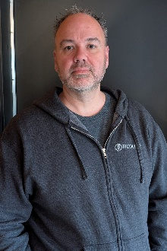 |  |  |  | 
Jean-Sébastien Brodeur  Operations Coordinator | Dominic Bachand  Security Coordinator | Martin Roussy  Admin. Services Coordinator | Roxanne St-Yves  Tournaments Coordinator | Valérie Lord-Joncas  Vie du Duché  Coordinator

Contact Us
https://bicolline.org/contact/

Registration and information
(819) 532-1755
info@bicolline.org
1480 Chemin Principal
Saint-Mathieu-du-Parc, QC, G0X 1N0
Team
Administrative Services : info@bicolline.org
Combat : combatGB@bicolline.org
Game: maitredejeu@bicolline.org
Security: securite@bicolline.org
Tournaments : tournois@bicolline.org
Urban Planning : urbanisme@bicolline.org
Vie du Duché : vieduduche@bicolline.org
Volunteers : benevolat@bicolline.org
Welcome : accueilGB@bicolline.org

Volunteers
Be part of a dynamic and passionate team during the Grande Bataille de Bicolline!
Every year, the Duché de Bicolline needs committed people to join our team of volunteers for the Grande Bataille de Bicolline. We’re grateful for the dedication these volunteers bring as they perform many of the tasks that help make it a unique event of international renown!
The process and advantages to being a volunteer are the same as last year. The Volunteer Policy for this year’s event is available in french on our website: https://bicolline.org/en/get-involved/ You’ll find all the information you need about volunteering during the Grande Bataille de Bicolline! You can also contact our Volunteer Manager, Cynthia Pinel, at benevolat@bicolline.org.

Volunteer Appreciation Evening
Our volunteer appreciation evening will be held at the Auberge on Saturday August 15th from 8:00 p.m. to 9:00 p.m. Each coordination will highlight their team’s noteworthy anecdotes and achievements!

Registration and Pricing
The 1026 edition of the Grande Bataille de Bicolline will take place from August 09th to 16th inclusively on the Duché de Bicolline’s site located at 1480 Chemin Principal, Saint-Mathieu-du-Parc, Québec, G0X 1N0.
Pets are not allowed on the Duché de Bicolline site.

To Participate
To take part in the Grande Bataille de Bicolline, you must :
- Know and abide by the values and policies of the Duché de Bicolline and recognize the need to adopt an attitude based on decency and respect to preserve harmony within the community:
- Our values;
- Sexual Violence Prevention and Management Policy.
- Know and comply with the combat rule and homologation standards if you wish to participate in combat activities. Documentation is available on our website :
- Combat Rules;
- Homologation Standards.
- Wear medieval/fantasy-inspired clothing at all times during the event and avoid anachronisms.
- Choose your registration package, complete the online registration and pay the fees. Please refer to the Registration and Rates section.
- Read and sign the Duché de Bicolline terms and conditions when you register.

Become a Member of the Duché de Bicolline
You can save on registration fees for Duché de Bicolline activities, including the Grande Bataille de Bicolline, by becoming a member. Information on the benefits of membership and how to become a member is available on our website: https://bicolline.org/en/participants-guide/membership-card/.

Registration and Rates
Registration for the 2026 edition of the Grande Bataille de Bicolline opens in May. Registration includes access to the site and activities (official program), as well as a designated site for your tent (modern or medieval) or access to your building.
Presale for the seven-day and three-day packages ends on June 13, 2026 at 11:59 p.m.
Please note that registration is limited:
- Seven-day and thee-day packages (including Early arrival or not): 5,000 participants.
- Discovery package (August 14th 2026): 2,000 participants.
Registering at the door is not possible, but registration remains open on the website as long as the limits have not been reached.
Table 1: Fee Schedule for the 1026 Grande Bataille de Bicolline
Package¹ | Members |  | Non-members
Package¹ | 16 and over | 10 to 15² | 16 and over | 10 to 15²
7-day package – Presale³ | 395,00 | 110,00 | 435,00 | 120,00
7-day package – Regular | 460,00 | 135,00 | 500,00 | 145,00
3-day package – Presale³ | 310,00 | 70,00 | 340,00 | 80,00
3-day package – Regular | 350,00 | 90,00 | 380,00 | 100,00
Discovery package  (Friday August 15th only) | 75,00 | 35,00 | 75,00 | 35,00
1-day Early Arrival⁴  (arrival on Saturday Aug. 9th) | 50,00 | Free | 50,00 | Free
2-day⁵ Early Arrival⁴  (arrival on Friday Aug. 8th) | 90,00 | Free | 90,00 | Free
1. All prices are before taxes and in Canadian dollars (Can$).
2. Children under ten years of age enjoy the event free of charge.
3. Presale ends on June 13, 2026 at 11:59 p.m.
4. Please refer to the Early Arrival section to view access terms and conditions.
5. Lifetime members enjoy the 1-day Early Arrival free of charge.

Parental Consent
Participants under 18 years of age must be accompanied by :
- A parent;
- A legal guardian; or
- A responsible person of 18 years of age or older. Where applicable, they must also provide a signed parental consent form, which must be handed to Duché de Bicolline staff on arrival at the Duché de Bicolline.
Parental consent forms are available on our website (in French only): https://bicolline.org/wp-content/uploads/2026/04/Autorisation-Parentale-2026.pdf.

Volunteers
If you are volunteering or thinking of joining our team, please wait until you receive the confirmation e-mail from the Duché de Bicolline before proceeding with your registration payment. Otherwise, your discount will not be associated to your account. Don't worry, your registration will be accounted for and you’ll be able to log in to your account to proceed with the payment once the discount has been applied.
Please refer to the Contact Us section to find out how you can join our team of volunteers.

Site Map
A map of the site and districts is shown in Figure 1 below. Please note that this map is currently being updated and is subject to change. The updated map will be available in July on our website: https://carte.bicolline.org/.

Figure 1 : Map of the Site and Different Districts
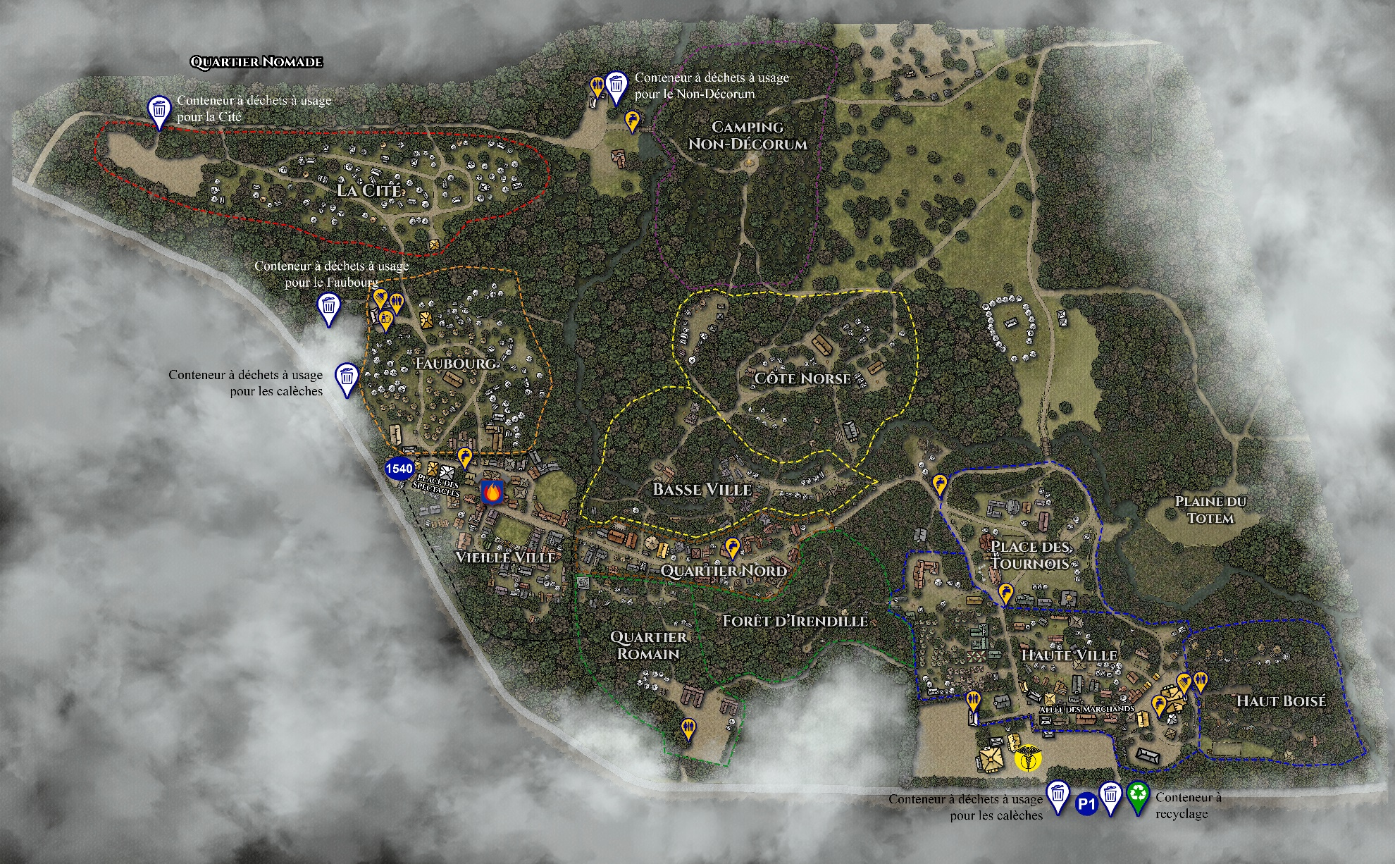

Site Access

Site Access and Shuttle Schedule
Upon arrival at the Duché de Bicolline site, all participants must check in at the Registration Building (Accueil) to receive their passes (bracelet). Participants may only check in during the opening hours detailed in Table 2. Only participants who have already received their bracelet can access the site outside these hours.
Shuttles to the P0 parking lot will also be available at these times (departing from the Registration Building only). Participants who lodge off-site must respect the shuttle schedule detailed in Table 2 if they need to access the P0 parking lot. The Duché de Bicolline will not make any specific arrangements for parking and access to the site. Please refer to the Parking section for additional information.
Table 2 : Schedules – Site Access and Shuttle Service to the P0 Parking Lot
Day | Site Access and Shuttle Schedules
Friday, August 7th (Early Arrival) | 10:00 a.m. to 6:00 p.m.
Saturday, August 8th (Early Arrival) | 10:00 a.m. to 6:00 p.m.
Sunday, August 9th | 9:00 a.m. to 8:00 p.m.
Monday, August 10th | 10:00 a.m. to 6:00 p.m.
Tuesday, August 11th | 10:00 a.m. to 6:00 p.m.
Wednesday, August 12th | 10:00 a.m. to 6:00 p.m.
Thursday, August 13th | 9:00 a.m. to 8:00 p.m.
Friday, August 14th | 9:00 a.m. to 8:00 p.m. for registration and P0 shuttle  Discovery Day participants can leave until midnight (no shuttle required)
Saturday, August 15th | Registration and drop-off landing are closed  P0 shuttle from 10:00 a.m. to 6:00 p.m.
Sunday, August 16th (departure) | 8:00 a.m. to 3:00 p.m.

Prémontage
The Prémontage will take place on Saturday, August 1st, 2026 from 9:00 a.m. to 6:00 p.m. It is not possible to sleep on site (neither on Friday nor Saturday) and you must leave the site by 6:00 p.m. at the latest.
This installation time is a privilege reserved for pre-registered participants who have paid their registration fee in advance. Please note that only participants who will be lodging in a building or those pitching their decorum tents will be allowed during this day: it is not possible to pitch tents or equipment in the non-decorum sector. The Prémontage is not dedicated to construction or repair work.
As we usually expect over 1,000 people during the Prémontage, we ask for your cooperation in order to be as efficient as possible. When you arrive :
- Go to the Registration Building (Accueil) and show your QR code or valid identity card to receive your bracelet.
- Make your way to your campsite. Please drive slowly.
- If you have a decorum tent to pitch, volunteers on site will confirm your location.
- Unload your equipment as quickly as possible.
- Drive your vehicle off the site, respecting traffic direction, and park it at the P1 parking lot (across the street of the Registration Building).
Before leaving at the end of the day :
- Clean up your campsite so it’s safe, decorum, free from debris and ready for the event.
- Deposit your household waste in the containers. Hazardous materials (canisters, used oil, construction materials, etc.) are prohibited in the containers: you must take this type of waste to an ecocenter. Please refer to the Containers section for locations and accepted materials.

Early Arrival
Early Arrival is a period of one or two days preceding the start of the Grande Bataille de Bicolline (Friday August 7th and Saturday August 8th, 2026).
This period is reserved exclusively for participants who meet the following criteria:
- Registered for the seven-day package and have paid their registration fees.
- Member of the Duché de Bicolline (family members must live at the same address to be eligible).
- Sleep in a building for the duration of the event.
Early Arrival registration includes an additional fee for participants aged 16 and over (please refer to the fee schedule presented in Table 1).
Note that :
- Early Arrival is not considered in play (there isn’t any official program).
- Participants do not need to be costumed during this period.
- The site is only accessible by vehicle for transporting equipment and material: vehicles must be moved as quickly as possible to the parking lot identified by on-duty Duché de Bicolline staff or volunteers.
- No deliveries of large items are allowed during Early Arrival (please refer to the Deliveries section).
- No tents (decorum or non-decorum) or tiny houses may be set up during Early Arrival (please refer to the Setting Up Your Camp section).

Departure
The official departure from the site takes place from Sunday August 16th at 8:00 a.m. Vehicles can only enter on the site at this time.
- When you leave the P0 parking lot, follow the directions for Chemin St-François: this will ensure better road safety for everyone.
- If your campsite is located in one of the following districts, you do not need to go back through the 1480 drop-off landing: Côte norse, non-decorum camping, Avant-poste, Faubourg, Cité, Quartier nomade and Quartier romain. Please refer to Figure 3 for a map of the site entrances and exits and the traffic direction.
If you need to leave the site at another moment during the event, please inquire at the Registration Building (Accueil) or with the Coordination Team. Please note that departures following the site access and shuttle schedule detailed in Table 2 will be greatly facilitated.

Parking
During the Grande Bataille 2026, only the following parking lots will be accessible. Staff and volunteers will indicate which parking lot to use on arrival.
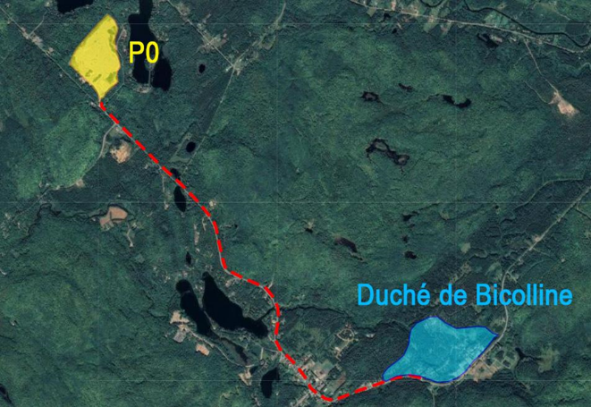
- P0 - Main parking lot served by a shuttle service throughout the event. The P0 parking lot is located 4.7 km from the Duché de Bicolline at the following GPS coordinates: 46.598084, -72.949080, approximately seven minutes away by car (please refer to Figure 2). Directions will be posted at the site exit and on municipal roads.
Figure 2 : Route from the Duché de Bicolline to the
P0 Parking Lot
There is little to no cell or network coverage at the P0 parking lot. As a result, Communauto-type rental vehicles may not start if you do not rent the vehicle for the entire event. Please check with your supplier.
- P1 - Reserved parking for vehicles with the appropriate parking sticker. Vehicles parked here without this sticker will be towed without notice.
- PB - Reserved parking for vehicles with the appropriate parking sticker. Vehicles parked here without this sticker will be towed without notice.
- Allotment (cession) parking - Allotment parking remains available during the event for guilds with access to it. Please note that the Duché de Bicolline does not manage these parking spaces.

On-Site Circulation

Vehicles
Vehicles may circulate on the site (following the site access schedule detailed in Table 2) during the Prémontage (August 1st), Early Arrival (August 7th and 8th), the first Sunday (August 9th) and the last Sunday (August 16th). You must always go through the 1480 drop-off landing in front of the Registration Building (Accueil) before entering the site with your vehicle unless you are accessing the following campsites or districts: Côte norse, non-decorum camping, Avant-poste, Faubourg, Cité, Quartier nomade and Quartier romain. The 1540 is an exit only and is not a drop-off zone.
To ensure everyone's safety, it is important to keep the main roads clear: vehicles, equipment, outdoor fireplaces, tents and ropes must not obstruct traffic in any way. An emergency services vehicle must be able to get anywhere on the site at all times.
We ask for your collaboration in order to :
- Always go through the 1480 drop-off landing in front of the Registration Building (Accueil) before entering the site with your vehicle unless you are accessing the following campsites or districts: Côte norse, non-decorum camping, Avant-poste, Faubourg, Cité, Quartier nomade and Quartier romain.
- Respect the site entrances and exits and the direction of traffic (please refer to the Figure 3):
1480 entrance (Registration Building/Accueil drop-off landing) to access the following districts: Haute Ville, Haut Boisé, Place des Tournois / Plaine du Monastère, Quartier Nord, Forêt d'Irendille, Basse Ville, Vieille Ville.
1562 entrance to access the Cité, Faubourg and Quartier nomade districts.
1400 entrance / exit to access the Côte norse and Avant-poste districts as well as the Plain des mages, the Fort and the non-decorum campsite.
1500 entrance / exit via 1501 to access the Quartier romain district.
1540 exit (no entrance) for vehicles having accessed the site via the 1480 and 1562 entrances.
- Always follow the instructions given to you by the Duché de Bicolline representatives in blue and yellow (staff, Coordination Team, volunteers, etc.).
- Do not leave your vehicle on the site: load your equipment and material as quickly as possible and park your vehicle so as not to obstruct the roads.
Figure 3 : Site Entrances and Exits and Direction of Traffic
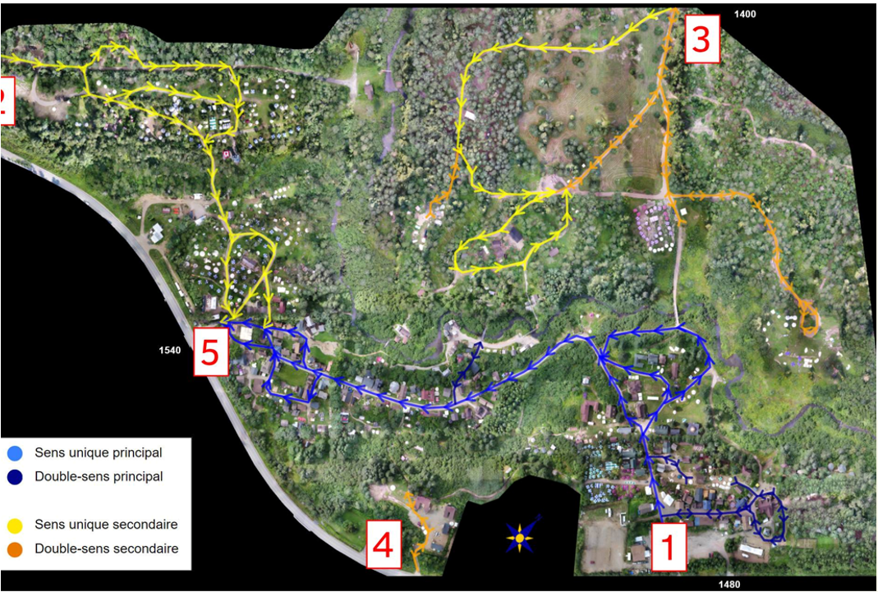

Equipment and Material Transportation During the Event
Vehicles may circulate on the site during the Prémontage (August 2nd), Early Arrival (August 8th and 9th), the first Sunday (August 10th) and the last Sunday (August 17th). Outside these periods, the Duché de Bicolline provides a horse-drawn carriage service to transport equipment to the desired campsite. There are two possible routes, depending on where your campsite is located (please refer to Figure 4).
Figure 4 : Carriage Routes for Transporting Material and Equipment
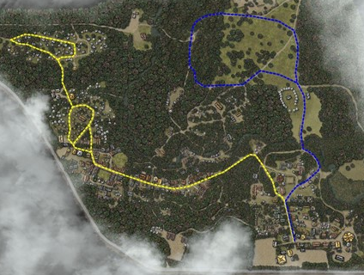

It's also possible to borrow a decorum cart to make moving your equipment easier. These are only available at the drop-off landing (in front of the Registration Building/Accueil). To ensure that the carts are returned to the drop-off landing once you have finished using them, the Accueil team will ask for an identity card and your population card for the duration of the loan. These two cards will only be returned to the borrower once the cart has been returned to the drop-off landing.
If you’re transporting materials or equipment while the site is in play and decorum, take care to camouflage your non-decorum personal effects (blanket, cloak, wooden chest, etc.).

Deliveries
Deliveries of large materials (wood, building materials, etc.) will be permitted up to and including July 31, 2026. Please plan accordingly.
For small deliveries during the event (caterers, parcels, etc.), we ask for your cooperation to :
- Respect the site access schedule.
- Pass through the 1480 landing stage (Accueil).
- Clearly identify the delivery (name, guild, etc.).
- Pick up on site at the 1480 landing stage (no deliveries to campsites).
- For catering services, please send an e-mail to accueilGB@bicolline.org with contact details (name, guild, supplier) and the day and time of delivery.
Please note that anyone entering the site must be registered (payment completed), have their bracelet and be costumed.

Accommodations

Setting Up Your Camp
Depending on your package and type of installation (decorum tent, modern camping tent, tiny house, guild building, etc.), you may face certain constraints when it comes to setting up your camp. Table 3 below is intended as a quick reference tool to help you prepare for your arrival at the Duché de Bicolline.
If you're moving materials or equipment while the site is in play and decorum, please take care to camouflage your non-decorum personal effects (use a blanket, cape, wooden chest, etc.). Please refer to the Equipment and Material Transportation During the Event section for additional information.

Table 3 : Setting Up Your Camp by Type of Accommodation
 | Building Under Allotment | Decorum Tent¹ | Rentals³ | Tiny House^{1,4} | Modern Tent (Non-Decorum)
Prémontage (August 2nd) | ü | ü | û | ü | û
Early Arrival  (Aug. 8th & 9th) | ü | û² | ü | û | û
1st Sunday (August 10th) | ü | ü | ü | ü | ü
Other days during the event | ü | ü | ü | û | ü
- Sites for decorum tents and tiny houses must be reserved in advance with the Urbanism team (urbanisme@bicolline.org). Please refer to the Reserve a Site section.
- Only decorum tents on a permanent platform can be pitched during Early Arrival. Please ensure your decorum tent is approved by a member of our Urbanism team once it is installed.
- Only Duché de Bicolline rentals (decorum pavilions and viking-style cabins). Please refer to the Rental Pavilions section for additional information.
- A pre-approved tiny house could be installed during the allotment weekend (cession) preceding the Prémontage (July 10-12, 2026). Please contact the Urbanism team to make a request (urbanisme@bicolline.org).

Guild Campsites
As the Duché de Bicolline is guild-based, many guilds have access to reserved sites and buildings built on the site (buildings under allotment). If you wish to have access to a guild's campsite for the duration of the event, you will need to research this yourself and make enquiries: the Duché de Bicolline cannot offer any suggestions in this regard. Social networks are a good way of making general requests if you don’t know any participants.

Tents and Tiny Houses
Several other options are available for on-site accommodations. In some cases, it is necessary to reserve your site in advance (decorum tents, tiny houses): please refer to the Reserve a Site section for additional information.
All tents, whether decorum or non-decorum, must be checked once installed to ensure that they are in the right place and comply with certain safety requirements (please refer to the Safety (Traffic and Fire Prevention) section). If all is in order, tents will receive an identification tag confirming it has been checked and is approved.

Safety (Traffic and Fire Prevention)
To ensure everyone’s safety, it is important to keep the main roads clear: vehicles, equipment, tents and ropes must not impede traffic flow under any circumstance. An emergency vehicle must be able to reach all areas of the site at all times.
All tents pitched on site during the Grande Bataille de Bicolline must be at least 10 feet (3 meters) from open flames and any sources of combustion (campfire, fireplace, grills, BBQ-type installations, outdoor torches, etc.). Never leave candles or other devices with live flames unattended inside a tent or on your campsite, even if they appear to be safely placed.
It is also strongly recommended to have a compliant fire extinguisher and first aid kit available at all times in or near your tent.
A tent that contravenes either of these two directives (traffic or fire prevention elements) is subject to being dismantled and/or removed without prior notice by a member of the Urbanism team or the Fire Prevention team.

Reserve a Site
To reserve a site for decorum tents and tiny houses, please send an e-mail to urbanisme@bicolline.org prior to the event. The Urbanism team will of course do its utmost to respond favourably to all requests received, but certain logistical or site constraints may mean that the desired location is not available.
With the ever-increasing number of tents and participants on site, we must now adapt our logistics to ensure fair accommodations for all. In order to optimize space and preserve harmony between guilds and participants, we ask for the collaboration of guilds and participants in implementing the following guidelines:
- No expansions for existing campsites: No matter how your guild evolves, the size of existing campsites will remain the same as last year. The Duché de Bicolline is not currently in a position to increase the size of existing campsites, but is already looking at short- and medium-term solutions to further develop the site.
- Prioritization of sleeping space: Sleeping space remains a priority, and it is requested that tents designed for this purpose be favored over communal tents (rest areas or shared kitchens, equipment storage, etc.). The Urbanism team reserves the right to refuse any communal tent if it compromises the layout of an allocated area or that of neighbouring areas.
Finally, in order to be as fair as possible to all participants, the priority for reserving sites for decorum tents is as follows:
- Guilds wishing to keep their previous year’s location.
- A new guild with no location, or a guild that wants a new location.
- Independent participants (without guilds) who wish to keep their previous year’s location.
- Independent participants (no guild) without a location or who want a new location.
- All other participants who have not reserved a site with the Urbanism team.

Decorum Tents
There are several categories of tents considered to be decorum, including :
Other types of decorum tents may be accepted at the Duché de Bicolline. If you have any doubts about the style or decorum of your tent, contact the Urbanism team (urbanisme@bicolline.org) with your questions and send a photo to make sure it’s suitable.
It’s only important to note that even if a decorum tent is approved, elements considered non-decorum or modern should still be hidden (e.g.: logos, highly visible zippers, plastic windows, other elements that reflect too much modernity, etc.). Tents made of green fabric (military tents), polyethylene or vinyl tarpaulins and other synthetic materials should also be avoided.

Bell tents | Pavilions | Prospector tents
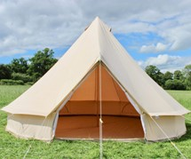 | 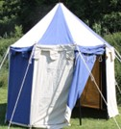 | 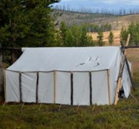
Tipis | Wedge tents | Viking tents
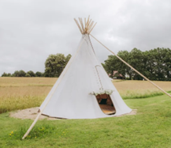 | 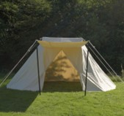 | 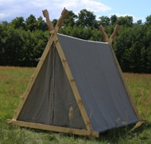

Bell-type tents - the most commonly used model in the Duchy - may require a large guying radius due to extensive rope anchoring. As of 2026, they must be equipped with decorative wooden stakes to reduce the space required for guy lines, while improving safety and optimizing space.
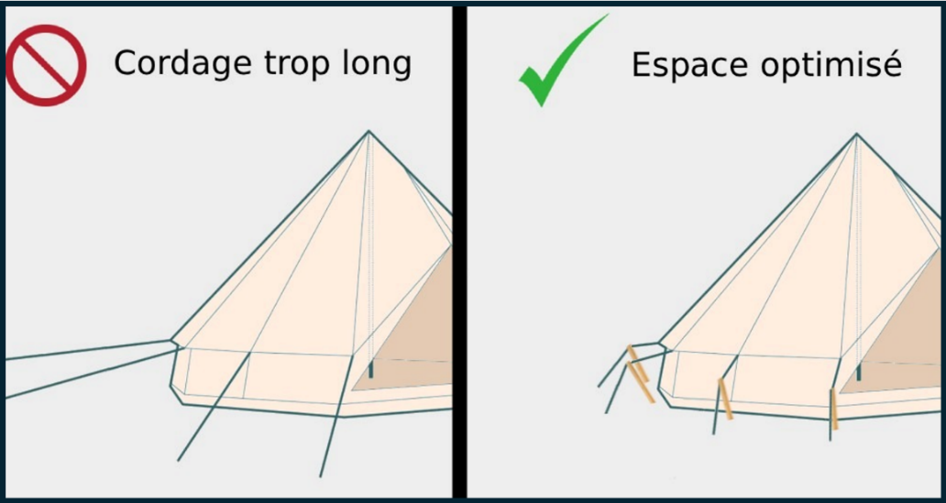
Any Bell tent that does not comply with this requirement may be required to be dismantled and relocated.

Non-Decorum Tents
The Duché de Bicolline site also has an area reserved for non-decorum tents: you can therefore bring your own modern tents (camping tents, “igloo” tents, etc.). The non-decorum camping sector is the only place where modern or non-decorum elements can be displayed during the event. All types of tents are accepted in this area and other camping equipment such as hammocks, tarpaulins, and camping chairs are also welcome. For the sake of other participants in the vicinity, however, it’s important to take up only as much space as you need as a large number of participants share this space every year.

Delimited by the yellow dotted line in Figure 5, the non-decorum sector is accessible via three separate paths, each about a five-minute walk from the main site:
- Blue dotted line: Access via the Plaine des mages / Fort;
- Green dotted line: Access via the Côte norse;
- Red dotted line: Access via the Cité.

Tents, security and instructions
Fire Hazard
All tents installed on the Grande Bataille site must be located at least 10 feet (3 meters) away from any campfire, fire pit, barbecue, or other potential fire source.
It is strictly prohibited to leave candles or any open flame unattended inside a tent, even if they appear to be safe.
Open-flame equipment is not permitted in the non-décorum camping area. The only authorized fire source is the outdoor fire pit located at the center of the area.
Circulation
Roads and main access routes must remain clear at all times, including from tents and guy lines. This measure is essential to allow access to emergency services if required.
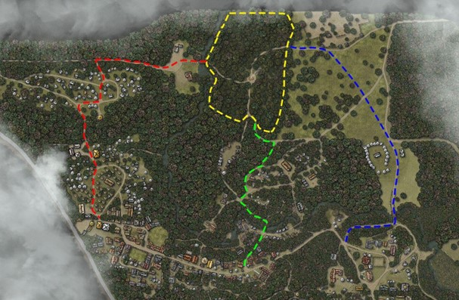
Any tent installed in non-compliance with these guidelines may be relocated or dismantled at the request of a representative from the Urban Planning Department or the Fire Department.
Figure 5 : Access to the Non-Decorum Camping Area

Tiny Houses
Tiny houses are booming in the Duché de Bicolline. These are trailers or other removable constructions on wheels that have been camouflaged and decorated so that they can be considered decorum. Tiny houses installed on the site must hide, camouflage or decorate certain specific modern elements: the license plate, the wheels, and the trailer hitch. In addition, due to space constraints and the narrowness of the paths on the Duché de Bicolline, tiny houses must not exceed the following dimensions:
- 8 feet wide (approximately 2.4 meters);
- 16 feet long (approximately 4.8 metres).
Tiny houses must be approved and registered with the Urbanism team prior to the start of the event (urbanisme@bicolline.org). It is also imperative to have confirmed the exact date of your arrival with the Urbanism team, as setting up a tiny house on the Duché de Bicolline site presents additional logistical challenges. Tiny houses that have not been approved by the Urbanism team will be refused access to the site.
With the exception of tiny houses that have been installed elsewhere for many years (please refer to the conditions detailed under Figure 6), all tiny houses will be installed in the Quartier nomade sector located near the Cité and delimited by the yellow dotted line in Figure 6. The Quartier nomade has around ten sites available for tiny houses and it is also possible to set up decorum tents nearby.
Figure 6 : Location of the Quartier nomade
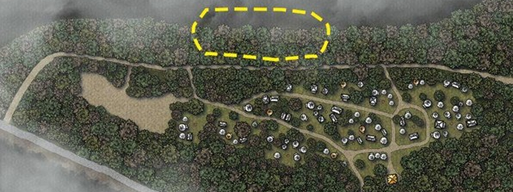
A few tiny houses have been installed outside the Quartier nomade for many years and the Urbanism team will do its best to allow them to keep their location provided the following criteria are met:
- The tiny house is affiliated with a guild that has a building or platform under allotment (cession) or has been lodging at the same location for several years.
- The tiny house complies with the safety rules detailed in the Safety (Traffic and Fire Prevention) section.
- The tiny house is set up during the Prémontage or the allotment weekend preceding the Prémontage (please refer to the Setting Up Your Camp section).
- The Urbanism team judges that the space is sufficient and does not encroach on the installation of other decorum tents.

Rental Pavilions and Viking-Style Cabins
The Duché de Bicolline also rents 55 decorum pavilions and 22 viking-style cabins. All rental pavilions and cabins are reserved for the 2026 edition.
Mostly located in the Faubourg, each rental pavilion is equipped with two cots and a storage trunk for your personal belongings. Nestled in the Côte norse area and along the path leading to the Avant-poste, each viking-style cabin is equipped with two cots, a storage trunk, and a LED lantern. Three packages are available: an eight-foot by eight-foot (8' x 8') cabin, a ten-foot by twelve-foot (10' x 12') cabin or a family package that includes two neighbouring cabins (one of each size).
All information is available upon request by writing to info@bicolline.org.

Trailers and Motorhomes
Vehicles of this type (trailers, motorhomes, vans, etc.) are not permitted on the Duché de Bicolline site, including in the parking lots. Several individuals, companies and organizations offer this service in St-Mathieu-du-Parc and the surrounding area.

Off-Site Accommodation
Several companies and individuals in the Mauricie region offer accommodation options outside the Duché de Bicolline. Participants who choose to stay off-site will not be provided with local parking: they must follow the shuttle schedule detailed in Table 2 in order to access the P0 parking lot, if applicable. The Duché de Bicolline will not make any specific arrangements for parking or access to the site.

River Access
There is no surveillance of the river access points, nor of the river itself. Swimming is at your own risk. Children must always be accompanied by a responsible adult.
No soap may be used in the river, even if it is environmentally friendly or biodegradable.

Well-Being and Safety

Duché de Bicolline Values and Policies
The Duché de Bicolline wants to ensure a healthy environment for its entire community and in recent years has been working to develop a framework for living well together:
- Our values: Seven core values guide the actions of the Duché de Bicolline: cooperation, sustainability, game ethics, involvement, inclusion, respect, and civic responsibility. These values guide us in our development and in the conception of all our activities.
- Sexual Violence Prevention and Management Policy.
It is with this objective in mind that we are currently developing a new Policy for the Prevention and Management of Violence, Harassment and Theft, which we hope will come into effect later this year. This policy will enable us to apply the values of the Duché de Bicolline and ensure the well-being of our participants.
Together, these two policies will identify guidelines for intervening and preventing violence in all its forms at the Duché de Bicolline.

Find Us During the Event
During the event, our staff will be on hand 24 hours a day at two locations on site:
- 1480 (Registration Building/Accueil): Caregivers available at all times at the dispensary, office staff during the day and surveillance team during the night.
- Vieille Ville:
- 1540 (site exit): Coordination team during the day and surveillance team during the night.
- Firehouse: Fire Prevention team available from 11:00 p.m. to 6:00 a.m.
Members of the Community Brigade and the Night Watch also patrol the grounds to ensure that the event runs smoothly and safely. Don’t hesitate to call on them if needed!
- In teams of two and following a predetermined schedule, the Community Brigade travels the site to meet participants and guilds, to take stock of the community and assess how the event is going as a whole.
- The Night Watch is also staffed by a small team of volunteers who travel the site after dark. The aim is to quickly target areas on the site likely to require interventions (dangerous terrain, out-of-control fires, general condition of a campsite or area, etc.).
We’ve been working closely with a number of community organizations in the region over the past few years, including CALACS Entraid'Action de Shawinigan/Mékinac/Haute-Mauricie, to better meet the needs of our community. We’re also continuing our collaboration with Tandem Mauricie, who will be on site at the Duché de Bicolline for several days to promote consumption-related awareness and prevention.

Caregivers
The Duché de Bicolline is a relatively isolated area, and the activities entail various risks (environmental, physical, related to fatigue or chronic illness, etc.). To enjoy the event in complete safety, we invite you to read the following. Your team of Caregivers will be very grateful!

Presence and Location
The team of Caregivers is available 24 hours a day from the Early Arrival. At least one person is available at all times at the dispensary located near the Registration Building (Accueil) and the remainder of the team roams the grounds according to the program and needs.
If you need to consult the Caregivers, go directly to the dispensary whenever possible. If you are unable to come to the dispensary, please send someone to notify the organization (dispensary, Registration Building, 1540, Firehouse, staff or volunteer with a radio), taking care to clearly identify the place where the Caregivers need to go, the name and description of the person who requires assistance, the issue, etc.

Level of Care
The Caregivers team is available to provide first aid only while waiting for emergency services, when required. Our teams do not offer medical follow-ups or dispense medication. You are therefore responsible for arriving at the Duchy of Bicolline with everything required to ensure a safe and high-quality event, including: a first aid kit, an emergency evacuation plan, and a sufficient supply of your medications. It is recommended to bring a small extra supply in case of loss.

First Aid Kit
To limit delays caused by health problems and reduce the pressure on our Caregivers team, you need to have an accessible first aid kit that includes, among other things, adhesive bandages and your own medication. This kit should be complete enough to treat a variety of common injuries, including: cuts, burns, foreign bodies in the eye, sports injuries (sprains), foot injuries (cuts, blisters, etc.), dehydration, heat stroke, hypothermia, and intoxication.
The Québec Commission des normes, de l'équité, de la santé et de la sécurité du travail (CNESST) is a good resource for determining your needs based on the number of people in your guild or group and the level of anticipated risk: CNESST - First Aid Equipment. You can also contact our team at securite@bicolline.org if you have questions or need additional information. Certain products will also be sold at the Market (limited quantities).

Emergency Exit Plan
While nobody wants to find themselves in this situation, you need to know in advance how and with whom you'll be able to leave the site if the need arises. Make sure you have an exit plan in case you need to leave the site: this includes arranging transportation, insurance, identifying a contact person -on site to help you, knowing the health resources in the area, etc.
- Have you communicated your emergency contact details and medical conditions to your guild members or friends?
- Do you have access to a car? Can you take a cab to Shawinigan? Can someone from out-of-town pick you up? All means are good, but it's important to plan ahead.
- Do you have insurance that covers ambulance costs? Please have this information and contact details with you, as neither the Duché de Bicolline staff nor the Caregivers team can take responsibility for transporting you to hospital in their personal vehicle.
- If you're from outside Québec, check to see how health care costs will apply to you. It's a good idea to take out insurance if you feel it's necessary.

Medication
Our Caregivers team cannot provide you with any medicine or medication, even if they are common. It is therefore essential to provide a minimum for your guild or group, including (but not limited to):
- What you need to treat your known illnesses (medication, prescriptions, medic alert-type devices, etc.).
- Ensure you have enough to last the event, with a little extra in case of loss, humidity, etc.
- If you use a protected needle device, make sure you have a safe container in which to dispose of your used needles and bring them back with you after the event. This type of item must not end up in the waste collected by our volunteer teams or in our containers.
- Be sure to bring a recharge or back-up system if you're using electrical devices such as a sleep apnea machine (CPAP).
- You must be independent in managing your medication. The infirmary cannot be used for supervised or extended medication administration.
- Antihistamines and everything you need to combat allergic reactions (medication, creams, auto-injectors, etc.).
- Allergens in St-Mathieu-du-Parc are numerous and, more importantly, may be different from what you're used to.
- If you have a severe allergy with the possibility of an anaphylactic reaction, please have your auto-injectors on your person at all times (EpiPen or other).
- Here are a few resources to help you plan ahead:
- Seasonal rhinitis (hay fever).
- Anaphylactic shock.
- Acetaminophen or ibuprofen.
- Medication to counter or treat diarrhea, heartburn, and nausea.
- Electrolyte tablets to prevent dehydration.

Alcohol and Drug Use
Be well prepared if you plan to consume alcohol or drugs: have a lid for your tankard or glass, be accompanied by someone you trust in case of intoxication, have Naloxone in your possession and know the procedure, etc. Naloxone is available free of charge at pharmacies. If you are going to drink alcohol and use drugs, please do it responsibly.

Consider Climatic Conditions
Weather conditions at the Duché de Bicolline can vary greatly from one day to the next. It's a good idea to be well-prepared to face them, with appropriate clothing and plenty of it:
- Hot weather: loose-fitting, light-colored clothing; wide-brimmed hat.
- Cold weather: several layers of clothing, including a windproof outer layer.
- At all times: good, closed-toe shoes.

Extreme Heat
It's a good idea to identify places in or near your campsite where you can stay cool (trees, shade, etc.), and always keep cold drinks on hand, especially if you’re taking part in tournaments or combat activities. Avoid consuming alcohol during periods of extreme heat.
Watch for heat-related symptoms:
- Headaches;
- Nausea or vomiting;
- Dizziness or fainting;
- Rapid breathing or heartbeat;
- Extreme thirst (dry mouth or sticky saliva);
- Less frequent urination accompanied by unusually dark yellow urine;
- Behavioural changes in children (drowsiness or tantrums).
If you suffer from these symptoms in hot weather, stay as cool as possible and drink hydrating fluids (ideally water). Ask to be fanned and apply cold water to large areas of your skin or clothing. You can visit the following site for additional information and tips: Health Canada – Extreme Heat.

Risks of Hypothermia
Although the Grande Bataille de Bicolline takes place in August, the risk of hypothermia is very real in St-Mathieu-du-Parc. Make sure you stay dry at all times. If you're cold :
- Find a source of heat (fire, warm blankets, move to a heated building like the Auberge, etc.).
- Drink hot, sweet beverages.
- Keep moving.
- Don’t fight shivering: it's one of the mechanisms by which the body increases its core temperature.
You can visit the following site for additional information and tips: Health Canada – Extreme Cold. This guide explains the three stages of hypothermia to help you identify symptoms.

Other Tips and Tricks
- If possible, keep your vaccines updated.
- Bring good, closed-toe shoes (at least two pairs) and avoid walking barefoot.
- Bring warm clothing even if the forecast remains high: nights are often very cool in St-Mathieu-du-Parc.
- Make sure you have eye protection if you're going to be on the battlefield (helmet, protective eyewear, etc.).

Important Addresses and Contacts
Table 4 : Important Addresses and Contact Information in Case of Emergency
Shawinigan Hospital and Emergency Services 24/24 – 23 min away
50, 119e rue
Shawinigan-Sud (Québec) G9P 5K1
Call 911
Nearby Pharmacies
Uniprix – 11 min away  3962, rue Trudel  Shawinigan (Québec) G9N 7Y6  (819) 539-9124 | Jean Coutu – 15 min away  2722, boul. Royal  Shawinigan (Québec) G9N 8M3  (819) 539-1119
Taxi services
Taxi Bellemare (819) 538-3000 | Taxi Shawi (819) 852-8294

Fire Prevention

Presence and Location
Our Fire Prevention team is available on site for the duration of the event. Mainly located near the Firehouse in Vieille Ville and reachable at all times by radio, this resource will be responsible for leading interventions combat fire hazards while awaiting the arrival of local services, for verifying the safety and conformity of firepits, and may have to assume any other function inherent to fire safety on the site.

Firepits and Torches
All installations must comply with our current regulations (in French only): https://bicolline.org/wp-content/uploads/2022/03/DossierFeu.pdf.

Fire Eaters and Fire Handlers
Any performance involving fire eaters and fire handlers must be authorized in advance. The exact procedure and forms will be available on our website: https://bicolline.org/en/bien-etre-et-securite/. Forms will also be available at the Firehouse during the event.

Fireworks
It should be noted that in accordance with Article 2 of the Règlement 2023-12 relatif aux feux en plein air de la municipalité de Saint-Mathieu-du-Parc, fireworks are prohibited on the territory of the municipality and, therefore, on the Duché de Bicolline.

Reporting an Incident
If you notice a fire in progress, please follow these few steps to report the incident and ensure a quicker response from on-site resources or emergency services. If you are safe and the fire is not out of control, you can also use a fire extinguisher to try to control the flames and reduce the spread of the fire (please refer to the Fire Extinguishers section).
- Call 911 if the fire is out of control.
- Report the event to the organization (1480 or 1540, Firehouse, person with radio), specifying :
- The nature of the event;
- Affected area, neighborhood, and/or building number;
- If people are in danger;
- Your name.
- Follow instructions from the 911 emergency operator and on-duty Duché de Bicolline personnel.

Fire Extinguishers
All buildings on the Duché de Bicolline must be equipped with a portable fire extinguisher. Owners of buildings under allotment (cessions) can pick up the fire extinguishers supplied by the Duché de Bicolline at the Registration Building (Accueil).
It's also strongly recommended to have a compliant fire extinguisher available at all times in or near your tent and tiny house.
To use a fire extinguisher :
- Remove the pin.
- Point the hose at the base of the flames.
- Press firmly on the control lever.
- Extinguish the fire, starting at a minimum distance of 10 feet (10') and moving towards the flames.
- Move to safety if the fire is too large or out of control.

Services

Waste Management

Site Maintenance and Cleanliness
The Grande Bataille de Bicolline is a success thanks to the constant involvement of its community of participants. In order to live together harmoniously on the site, we must all make a collective effort to manage our own waste. Service points, common areas, and rest areas are not serviced by dedicated cleaning teams: please collect your own garbage when using these installations. Thank you for your understanding.

Containers
To ensure cleanliness during the event, there are several waste containers available as early as the Prémontage or Early Arrival. They are located in the following areas: P1 parking, 1540, Faubourg, Cité, and near the toilets for the non-decorum sector (please refer to Figure 1 and Figure 7). We are currently evaluating the installation of a recycling container; information will be available during the event.
Please bear in mind that the Duché de Bicolline is not an ecocenter and that you are responsible for sorting the materials you put in the containers. Do not include hazardous materials (canisters, used oil, construction materials, etc.). You must take these materials to an ecocenter: https://www.enercycle.ca.

Waste Collection (Garbage)

Challenges and Objectives
Organizing a large-scale event such as the Grande Bataille de Bicolline represents a real logistical challenge and waste management is one of the most complex and often underestimated aspects. A number of factors make this task particularly difficult, including the large number of participants and campsites to be serviced, the vastness of the site and its accessibility for the horse-drawn carriages carrying out the collection, and the lack of volunteers willing to undertake this task. We are therefore asking for the cooperation of guilds and participants to limit the amount of garbage to be processed on site during the event and, most importantly, to avoid leaving bags along the main paths.
The collection of household waste therefore requires rigorous planning, good team coordination, and a high level of awareness among participants. Several initiatives, some of which are detailed in the following sections, are therefore being introduced or emphasized this year:
- Waste management by the restaurant owners.
- Reduction or removal of single-use items, including plastic glasses, paper napkins, and utensils.
- Collection of returnable containers (please refer to the Collection of Returnable Containers section below).
- Reinforcement of self-service for sectors located near containers, in force since 2024.
- Continued collection by our volunteers for sectors located far from containers.
- The development and implementation of an in-game emulation system to encourage initiatives by guilds and participants.

Self-Service for Sectors Located Near Containers
Since 2024, our waste collection teams have been prioritizing sectors and campsites that don't readily have access to a container. We therefore ask guilds and campsites located near containers to dispose of their garbage there themselves. Figure 7 identifies the container locations on the site and the level of service offered for each sector.
To encourage immersion during the event and to avoid having the main paths being constantly dotted with people carrying garbage bags, it is requested, where and when possible, that particular attention be paid to camouflaging the bags (e.g.: decorum cart, jute covering or other material, etc.) or to the time of transport and deposit (e.g.: in the morning before the start of the majority of activities). Thank you for your understanding and efforts.

Waste Collection for Sectors Far from Containers
Our teams of volunteers make three daily collections during the event (Monday to Saturday inclusively). They travel part of the site (sectors in yellow in Figure 7) in a decorum horse-drawn carriage to collect your garbage bags.
Since our team uses a horse-drawn carriage, precise schedules are not available: be on the lookout for them in your sector! Participants are invited to put their own bags in the carriage directly.
Table 5 : Collection Schedule (Monday to Saturday)
Garbage | Returnable containers
10:00 a.m. to 2:00 p.m. | 2:00 p.m. to 4:00 p.m.

Les Farfouilleurs: In-Game Garbage Collection
A new system for collecting household waste will be introduced in 2026. Created to encourage participants to manage their own garbage, this in-game collection will take place at the Préau located in the Faubourg from 11:00 a.m. to noon. Non-player characters (NPC) will be on hand to exchange with participants who agree to play the game and drop their bags directly into the nearby container. Participants who meet certain criteria or impress the NPCs with their level of play will be rewarded. Full details are available in the Game Document.

Figure 7 : Location of Containers and Identification of the Sectors
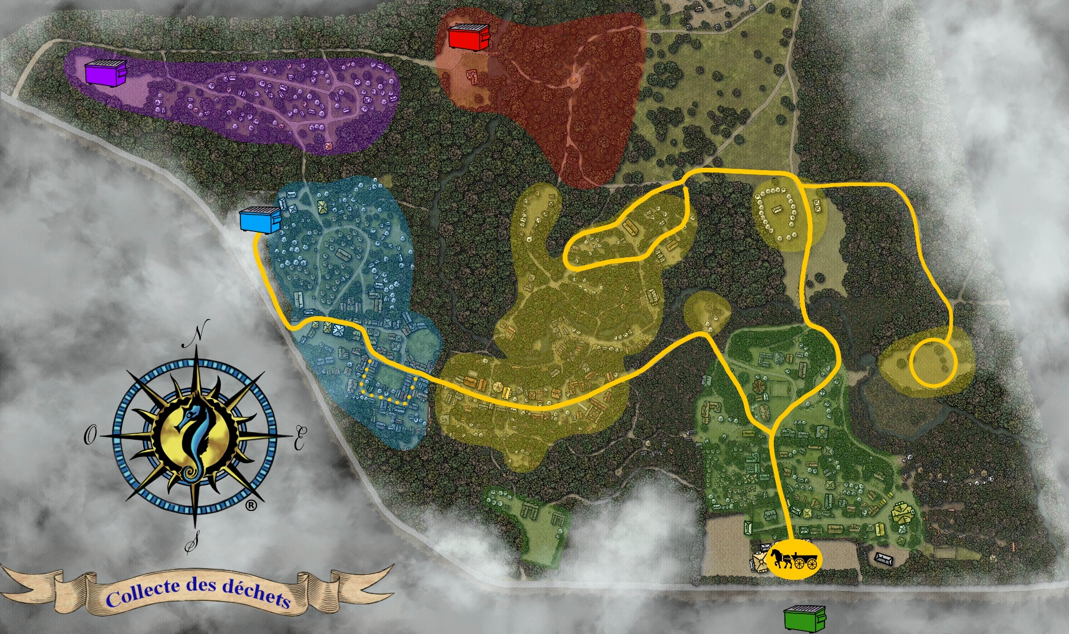
Legend (identification of sectors and service offering) :

n Yellow sectors : Waste collection by our volunteers
n Green sectors : Self-service to the container located in the P1
parking lot
n Blue sector : Self-service to the container located in the Faubourg
n Purple sector : Self-service to the container located in the Cité
n Red sector : Self-service to the container located near the
non-decorum toilets
— Yellow line : Horse-drawn carriage route

Technical Specifications
We also ask for your cooperation to avoid breakages (bags, carriages, etc.) and injuries. Our volunteers will refuse bags they deem unsafe. Therefore, please consider the following:
- Limit the weight of your bags (if you find them heavy, so do our volunteers!).
- Use quality bags for your waste: contractor black or white garbage bags, 3 mm thick, 113 liters / 30 gallons maximum (approximately 30”x36”).
- Use clear or blue recycling bags for your deposits: maximum 125-litre / 33-gallon bags.
- Do not include hazardous materials, gray water, or black water in your garbage bags or in the containers. (please refer to the Containers and Wastewater Management sections).

Collection of Returnable Containers
Our teams collect returnable containers from the entire site. This is usually done at lunchtime or in the early afternoon.
- Please help them by separating your returnable containers from your garbage and, if possible, rinsing them and placing them in a transparent bag.
- All proceeds will be reinvested to improve facilities and equipment for youth activities (Clos des flos).

Wastewater Management
Wastewater (gray water and black water) must not be discharged on the Duché de Bicolline site and must not be included in your garbage or disposed of in the waste containers. The Duché de Bicolline is not equipped to handle participants’ wastewater.
For the sake of the environment and the sustainability of the site, you must take these materials with you and dispose of them safely in the designated areas:
- https://www.stationvidangevr.com/
- https://www.environnement.gouv.qc.ca/publications/note-instructions/13-02.htm

Dismantling
When leaving the site, please remove all ropes attached to trees and collect all debris, including glass. The teams responsible for site maintenance are exposed to a high risk of injury. It is your responsibility to leave the area safe and to respect the environment.

Sanitary Installations
The location of the following sanitary facilities is shown on the site map in Figure 1 :
- Chemical toilets (porta potties) are available in various areas: near the Registration Building (Accueil), in the Faubourg, and near the non-decorum and Cité. Chemical toilets in the Côte norse, Avant-poste, and Quartier romain sectors are reserved for the sole use of nearby guilds (thank you for your understanding).
- There are two sanitary installations with showers at either end of the site:
- Auberge (Haute Ville) :
- Open at all times (24/7) with temporary closures during daily cleaning.
- Access cards are on sale at the Market (6.00 Can$).
- Faubourg:
- Open from 7:00 a.m. to 10:00 p.m. every day with temporary closures during maintenance (if required).
- Access and payment by credit card reader (6.00 Can$).
- There is a dish-cleaning station next to the Faubourg toilet block.
- Open from 7:00 a.m. to 10:00 p.m. every day.
- Food must not be dumped in these stations. To avoid clogging the drains or breaking the installation, please remove all organic or solid waste from your dishes before using the sinks.
Any changes made to sanitary installations after publication of this document will be posted on our website: https://bicolline.org/en/sanitaire/.

Craftsmen and Merchants
In the Haute Ville district, you'll find a host of stores and craftsmen offering a wide range of equipment, armor, costumes of all kinds, swords and other fantastic weapons, as well as a host of accessories for role-playing games and medieval immersion activities. Come and discover the merchant buildings permanently installed on the Duché de Bicolline. Dozens of other stalls and merchant pavilions will set up store for the duration of the event.
To conduct real-money transactions on the site, you must hold the necessary sales permit and authorization. To participate in the event as a craftsman or merchant, please contact us at info@bicolline.org. Craftsmen and merchants who will be present during the event will be available on our website in the coming weeks: https://bicolline.org/en/artisans-2026/.

Food Services
There are several authorized service points on the Duché de Bicolline site where food and drink can be purchased. Information on suppliers and opening hours will available on our website in the coming weeks: https://bicolline.org/en/offre-alimentaire-2026/.

Restaurants
On-site restaurants and catering services are provided by a number of suppliers in both Haute Ville and Vieille Ville. Suppliers will be added to our website as food services are confirmed.
We wish to remind you that since last year:
- Suppliers are reducing and eliminating certain single-use items (plastic glasses, paper napkins, and utensils, in particular): bring your own!
- Priority access is given to on-duty staff and volunteers. Thank you for your understanding!
We also appreciate the efforts of participants who bring their own reusable decorum cutlery! And don't forget to dispose of your garbage in the garbage cans near the restaurants.

Marché, Auberge and Vieille taverne
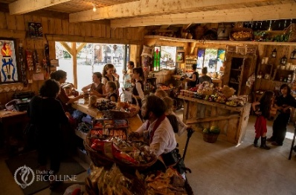
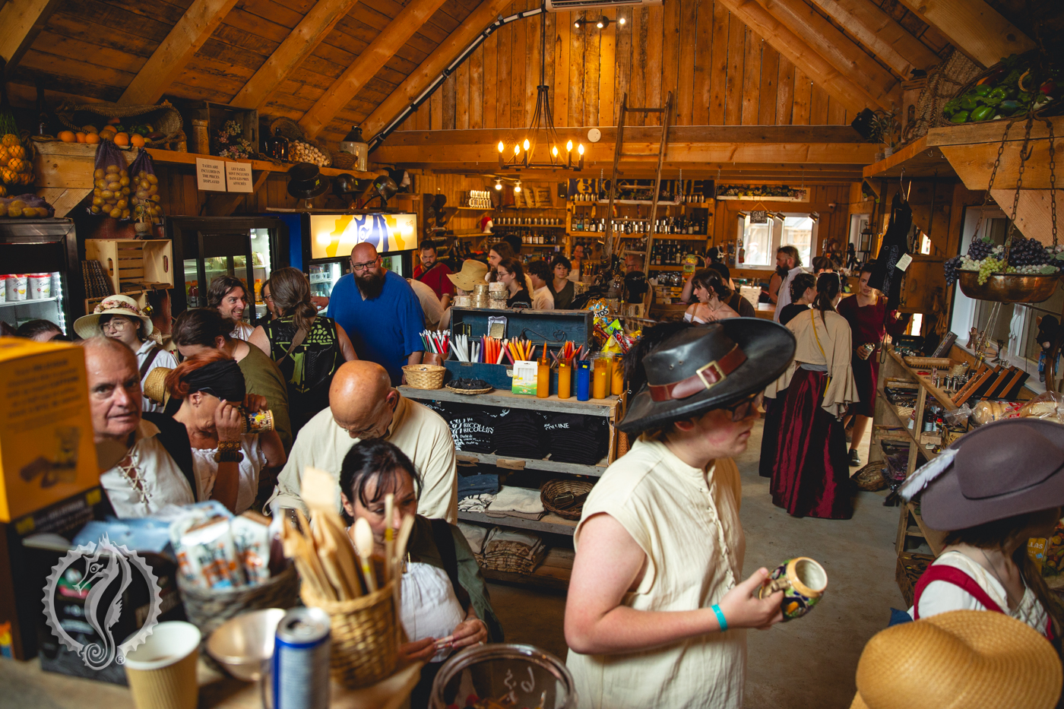
Located across from the Auberge in Haute Ville (near the Allée marchande), come discover the Marché (Market), a unique shop offering fresh food, bags of ice, Duché de Bicolline promotional items, everyday products such as soap and bags for trash and returnable containers, some basic health products (first aid kits, bandages, etc.) and various unique products.
The Marché's coffee counter offers hot drinks, pastries, fresh bread and cold slushies every day.

Snacks and refreshments (alcoholic and non-alcoholic beverages) are also available at the Auberge (Inn) located in Haute Ville and the Vieille taverne (Old Tavern) located in Vieille Ville. The Vieille taverne also sells ice!

Table 6: Marché, Auberge and Vieille taverne Opening Hours
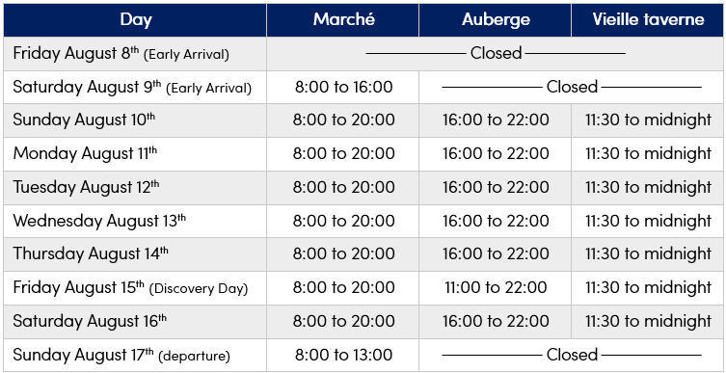
**Please note that the Market (Marché) is closed every day between 1:30pm (13h30) and 2:30pm (14h30)**

Accepted Payment Methods
Accepted payment methods on the Duché de Bicolline site vary by location and vendor, according to the information provided in Table 7. There are no ATMs on-site and cash withdrawals are not possible.
Table 7 : Accepted Payment Methods
Location | Cash¹ | Debit Card | Credit Card²
Accueil (Registration) | ü | ü | ü
Marché (Market) | ü | ü | ü
Auberge (Inn) | ü | ü | ü
Vieille taverne (Old Tavern) | ü | ü | ü
Faubourg Showers | û | û | ü
Craftsmen, merchants, and restaurants | Some offer payment by debit card, credit card, or Square,  but many only accept cash¹ .
- Canadian currency only.
- Visa et Mastercard only.

